Non-invasive Assessment of Mesenteric Arterial Hemodynamics with 4D flow MRI

¹A Roldán-Alzate; ¹CJ Francois; ¹B Landgraf; ²CW Acher; ^{1,3,4,5}SB Reeder; ^{1,2}O Wieben
Departments of ¹Radiology, ²Surgery, ³Medical Physics, ⁴Medicine and Biomedical Engineering
University of Wisconsin – Madison, USA

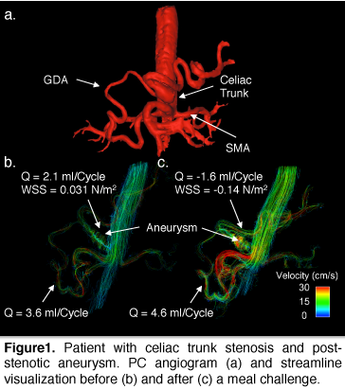
Introduction: Chronic mesenteric ischemia (CMI) is a pathology typically revealed by abdominal pain that appears 15 to 60 minutes after a meal. CMI is associated with nausea, vomiting and fear of food, which lead to significant weight loss. The most common cause of CMI is atherosclerosis, however median arcuate ligament syndrome (MALS) has also been related to it. The diagnosis of MALS from traditional angiography approaches is very challenging because some degree of compression from the MAL onto the celiac artery is considered normal and difficult to differentiate from a compression that causes symptoms. Evaluation of mesenteric ischemia is further complicated by the rich network of mesenteric collaterals available from the superior (SMA) and inferior (IMA) mesenteric artery, which in some patients, may compensate for decreases in flow through the celiac axis. For these reasons, proper evaluation of these conditions has been challenging and treatment has been dramatically limited. In this pilot study, we investigate the use of 4D flow MRI to improve diagnosis by providing simultaneous anatomical depiction and functional assessment of the hemodynamics before and after a meal challenge.
Methods: In this IRB-approved and HIPAA-compliant study, four patients with celiac trunk stenosis were imaged.on a clinical 3T scanner (Discovery MR 750, GE Healthcare, Waukesha, WI). 4D PC MR data were acquired before and after a meal using 5-point PC VIPR acquisition [2,3] that covers the vasculature of the entire upper abdomen: imaging volume: 32x32x24cm spherical; 1.25mm acq. isotropic spatial resolution; TR/TE=6.4/2.2m; intrasvacular contrast agent (0.03mmol/kg of gadofosveset trisodium (Lantheus, N. Billerica, MA)). All imaging was performed after at least 5 hours of fasting. After the first scan, subjects orally ingested 574 mL EnSure Plus® (Abbot Laboratories, Columbus, OH; 700cal) orally. Scanning was resumed 20 min after the meal challenge. The 4D PC VIPR data were analyzed for anatomy (PC angiogram), flow measures, and wall shear stress (WSS) in several vessel segments using commercial and customized software packages.
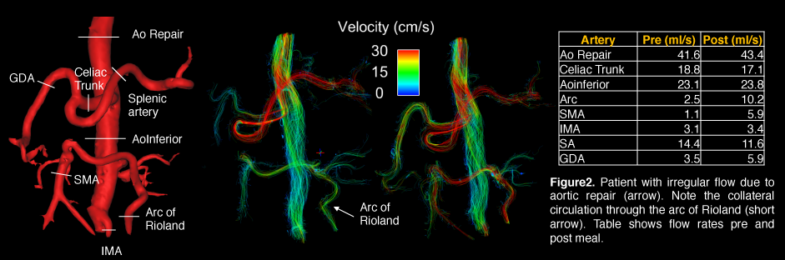
Results: 4D MR flow data were successfully obtained from all 4 subjects. Here we will concentrate on the results from two of the patients. In the first patient, stenosis of the celiac trunk as well as an aneurysm were identified (Fig1). Flow in the gastroduodenal (GDA) artery was retrograde and increased by 28% after the meal while WSS within the aneurysm increased 4.5 fold after the meal. The second patient revealed collateral circulation through the arc of Rioland (Fig2). In this patient, the mesenteric hemodynamics did not change drastically in response to the meal, however the collateral blood flow through the arc of Rioland increased 4-fold.
Discussion: This pilot study demonstrates the capabilities for PC VIPR to characterize and quantify complex vessel anatomy and hemodynamics in the entire hepatic and mesenteric circulation as well as inherent anatomical co-registration from a single scan. Not surprisingly, we did encouter very patient-specific responses to the meal challenge. Based on these encouraging results we are currently enrolling additional patients to investigate the use of PC VIPR for possibly improved diagnosis and patient management.
References: [1] A René. J Vasc. Iterv. Rad. 2011, [2] T Gu AJNR 2005 [3] KM Johnson MRM 2010, [4] A. Stadler MRM 2008.
1. My preferred presentation type is:

Oral

2. Keywords:

Celiac trunk stenosis, 4D flow, abdominal pain

3. I am eligible for the Potchen Award

No

